2018 ~ 2019 PRE CALCULUS SYLLABUS
Teacher: Mrs. Walton
Room 615
Course: Pre Calculus
Textbook (when needed): PreCalculus: Graphical, Numerical, Algebraic, 6th edition

COURSE CONTENT: Pre-Calculus builds upon topics covered in Algebras 1, 2 and Geometry. Additional topics include analytical geometry, trigonometry, vectors, polar coordinates, and introductory calculus. Problems are linked to real-world applications with an emphasis on graphing, vocabulary, and technical writing. This course is designed to prepare students for calculus and college mathematics.

Various learning and teaching styles will be utilized throughout the course of the trimester. Students can expect to be involved in group activities, whole-class and small-group discussions, individual/independent activities, teacher-led discussions, model-and-learn sessions, and student presentations, to name a few. In general, students should expect to be actively engaged in learning during class. Students should expect 15-60 minutes of homework four times a week on average. Study time outside of class for tests will be expected.

Expectations/Responsibilities:
- All materials and supplies must be in as good as shape or better when they are returned.
- Always listen attentively while others are addressing the class.
- Be actively engaged in learning.
- Bring the proper materials to class including, but not limited to, text, notebook, and PENCIL.
- Always work 100% of the time.
- Treat all individuals with respect and courtesy.
- Take pride in your work, but have a humble, compassionate, and teachable attitude.
- Always be on time, if you are absent, it is YOUR responsibility to come and make up the work.
- Have all homework completed at the beginning of the class period in which it is due.

Materials Information:
It is strongly recommended to have a 3-ring binder to keep track of papers, notes and homework. This binder should be only used for math class. Organization is the key and will aid you in homework and studying for quizzes and tests. All work must be done in pencil. No credit will be given to work completed in any other fashion unless prior approval has been given. Students who have not done so should strongly consider purchasing a graphing calculator for use this year and in the future. (The TI-83 and TI-84 families of calculators are the most versatile-see me for more details.) Calculators will be available for use in the classroom, and a program has been set up by the math department and the library to check out calculators on a nightly basis.

Classroom Expectations:
#1: You are expected to be ON TIME.
#2: You are expected to treat EVERYONE in the class with the same attitude of respect you expect to treated. This
includes the language you use, the attitude you bring to class, and the way you respond when asked to do something in class.
#3: Personal music players will not be used during class.
#4: Any other questions or inquires will be handled according to the student handbook.

Consequences: Failure to follow the rules and procedures will result in any of the following:
1. Warning … Student – Teacher conference …
2. Parent contact and/or detention
3. Referral to an Administrator

Grading System:
The math department utilizes a weighted grading system:
- Formative assessments (daily work) will make up 20% of your grade.
- Summative assessments (Quizzes and Tests) will make up 80% of your grade.

- The Final exam will be cumulative and worth 20% of your trimester grade.

In other words: 0.80*(12-week grade) + 0.20(Final Exam grade) = Trimester Grade

Grading Scale:
A standard grading scale is as follows:

 | 87 ≤ B+ < 90 | 77 ≤ C+ < 80 | 67 ≤ D+ < 70
93 ≤ A ≤ 100 | 83 ≤ B < 87 | 73 ≤ C < 77 | 63 ≤ D < 67
90 ≤ A- < 93 | 80 ≤ B- < 83 | 70 ≤ C- < 73 | 60 ≤ D- < 63
 |  |  | 0 ≤ F < 60

Missed Class time/Absences:
If a student misses a class, regardless of the reason, it is his/her responsibility to make up the work. It is expected that any student who is absent will discuss missing assignments/work with the instructor upon return. If a student is absent on a day in which an assignment is due, the assignment will be due upon return to class. If an assignment is given while a student is absent, the student will then have the length of absence in days to hand-in the work, before it will be considered late.

Please be aware that the Attendance Policy has changed regarding maximum absences and passing this class. Please refer to your student handbook (also found online) for this policy.

Leaving Class:
It is very important to be in class and prepared to learn. If the situation arises that a student must leave class to use the restroom or run an errand, permission must be granted by the teacher. A student must have his or her planner in order to leave the classroom. The teacher will keep track of time each student is out of class. If this privilege is abused, the teacher has the right to take it away or assign a detention to make up for missed class time.

Deadlines and Due Dates:
Homework assignments need to be handed in at the beginning of the class period of which they are due. If a homework assignment is handed in after this time, it is considered late (see absence section above for exception). You may hand in an assignment up to one week late, for ½ credit of your graded score. Homework more than one week late will not be accepted.

Quizzes may not be retaken. For quizzes in the same chapter the following applies: if you score higher on quiz #2 than quiz #1, your higher score will replace the score immediately preceding it (and you’ll have two scores that are the same). If you score higher on quiz #3, it will replace quiz #2 and so on…. Since math is cumulative, showing mastery as the chapter progresses is our goal.

Unit Tests: The unit test can replace the quiz immediately preceding it (see above procedure). You have the option to retake ONE Unit test each trimester.

- Tests and Quizzes MUST BE completed in one sitting. You will not be able to finish in PASS or the next day.

To receive text message reminders:

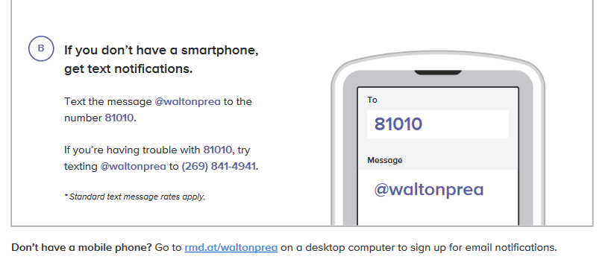

- TO BE COMPLETED BY YOU AND YOUR PARENT --- Syllabus

By signing this page, I show that I have read and understand all the information in Mrs. Walton’s syllabus for Pre Calclulus A 2018-2019. I understand the grading criteria and will abide by the classroom expectations that are described.

Student Name (printed) _____________________________________

Student Signature__________________________________________

Parent/Guardian Signature___________________________________

- TO BE COMPLETED BY YOUR PARENT --- Contact information

Parent Name(s) (printed) _____________________________________

Parent Email(s) __________________________________________________________________

Parent Phone Number(s) _____________________________________

Preferred method of contact (email or phone) _____________________________________

3. PARENTS—Please consider signing up for “Remind”, a communication from me to your student regarding homework, quiz and test reminders. You’ll know what students are doing in class and when they have homework! For text reminders, just text the code to the number below, for email reminders, please contact me.
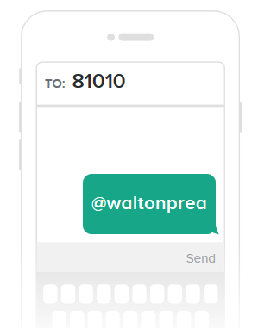

This page of the syllabus is due on the first Friday of the trimester.

