Geometry A Parchment High School
Room 615 Mrs. Walton
Contact Information and Availability
Email: swalton@parchment.k12.mi.us Phone: (269)488-1158
Web: www.waltonmath.weebly.com

Course Description
Geometry is a two-trimester class that develops reasoning and problem-solving skills while focusing on the essential concepts of geometry. Although the class is divided into units, course concepts and skills are reinforced and revisited throughout both trimesters. You will also have the opportunity to practice and improve your algebra skills by using them to solve geometric problems.

The Common Core State Standards will guide our work together this year. The #1 Standard for Mathematical Practice: Make sense of problems and persevere in solving them. Be prepared to practice persevering!

Units include: Shapes and Transformations, Angles and Measurement, Justification and Similarity, Trigonometry and Probability, and Congruent Triangles

Classroom Rules
- Come to class on time and prepared to work.
- Respect all students and adults, as well as class equipment.
- Follow directions the first time they are given.
- Stay focused and on task.
- Only talk when appropriate, and adjust your volume according to the activity.

All school rules in the student handbook are also enforced in this class.

Personal electronic devices are only allowed during appropriate times during class. We will go over this extensively during the first weeks of school.

What to Expect in Class
You will often have a short assignment/warm-up activity to do when you enter the classroom. This introduces the day’s key concepts and is to be completed individually. Please be in your seat, silently working on the warm-up, when the tardy bell rings. Homework is due at the beginning of class and needs to be on your desk while you are completing your warm-up.

Class activities will take a variety of forms throughout the trimester. You will frequently work with others, both in pairs and in groups, and it is essential that you contribute ideas, questions, and a positive attitude to your team. Technology will be utilized heavily in order to help you explore and visualize course content.

Most days, there will also be an exit pass activity. This helps me to gauge the learning that has occurred that day and to plan the next day’s activities. You will have homework 2-5 times a week. The purpose of homework is to help you identify your strengths and weaknesses so that you can get help when necessary.

The best way to be successful in this class: Listen, Participate, and be HERE.

What I Expect from YOU
You will contribute to class learning by sharing your ideas, asking questions, and working hard. You will persevere through the challenge of problem-solving.

Consequences for Problem Attitudes and Behaviors
In most cases a verbal warning should be sufficient to remind you of classroom rules and procedures. In the event that you choose to continue with an inappropriate attitude or behavior, we will discuss the issue after school in detention. I will also call your parents to discuss strategies for resolving the situation.
Required Materials
Book: Big Ideas Geometry, Larson & Boswell, 2014
Student Journal
Folder
Pencil with eraser

Recommended Materials
Calculator-graphing calculator or scientific calculator

Missed Class time/Absences
If you miss class, regardless of the reason, it is your responsibility to make up the work. Missed work can be found in the file folders in the front of the room. You have one day for each day of absence to hand in work before it is late.

Please be aware that the Attendance Policy has changed regarding maximum absences and passing this class. Please refer to your student handbook (also found online) for this policy.

Leaving Class
Six bathroom passes are available each trimester. You must ask permission first, and passes will not be granted the first or last 15 minutes of class or on days when you are tardy.

Grading System
The Math Department has a weighted grading system. Your trimester grade consists of:
- Formative: activities, homework, and check-ups (25%)
- Summative: Quizzes and Tests (75%)

This trimester work makes up 80% of your overall grade, and your final exam makes up 20%.

In other words: 0.80*(12-week grade) + 0.20*(Final Exam grade) = Trimester Grade

Grading Scale
The standard grading scale is as follows:
 | 87 ≤ B+ < 90 | 77 ≤ C+ < 80 | 67 ≤ D+ < 70
93 ≤ A ≤ 100 | 83 ≤ B < 87 | 73 ≤ C < 77 | 63 ≤ D < 67
90 ≤ A- < 93 | 80 ≤ B- < 83 | 70 ≤ C- < 73 | 60 ≤ D- < 63
 |  |  | 0 ≤ F < 60

Quizzes may not be retaken. For quizzes in the same unit the following applies: if you score higher on quiz #2 than quiz #1, your higher score will replace the score immediately preceding it (and you will have two scores that are the same). If you score higher on quiz #3, it will replace quiz #2 and so on…. Since math is cumulative, showing mastery as the unit progresses is our goal.

Chapter Tests may be retaken. However you must first stay a minimum of one session after school with me to re-teach, and you must re-take the test after school (not during school hours). You have five days after the original test is returned to complete the re-teach session and to re-take the test. The maximum grade on a re-test is 89%.

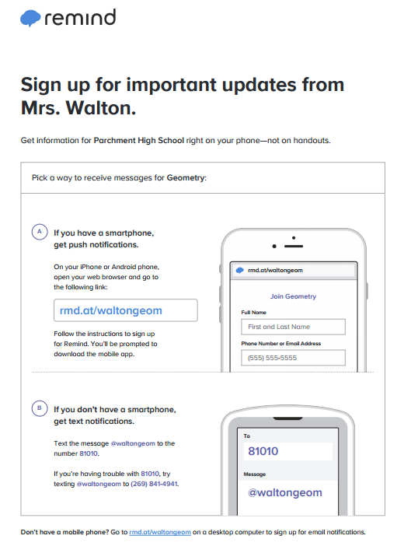

- TO BE COMPLETED BY YOU AND YOUR PARENT --- Syllabus

By signing this page, I show that I have read and understand all the information in Mrs. Walton’s syllabus for Geometry A 2018-2019. I understand the grading criteria and will abide by the classroom expectations that are described.

Student Name (printed) _____________________________________

Student Signature__________________________________________

Parent/Guardian Signature___________________________________

- TO BE COMPLETED BY YOUR PARENT --- Contact information

Parent Name(s) (printed) _____________________________________

Parent Email(s) __________________________________________________________________

Parent Phone Number(s) _____________________________________

Preferred method of contact (email or phone) _____________________________________

- PARENTS—Please consider signing up for “Remind”, a communication from me to your student regarding homework, quiz and test reminders. You’ll know what students are doing in class and when they have homework! For text reminders, just text the code to the number below, for email reminders, please contact me.
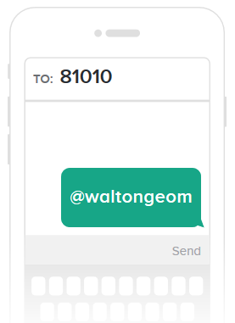

This page of the syllabus is due on the first Friday of the school year.

